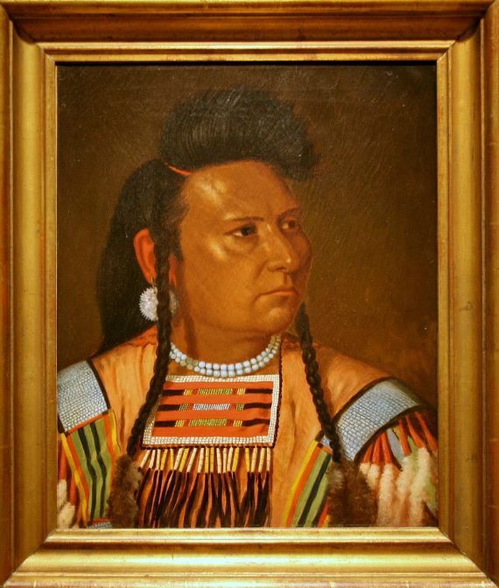 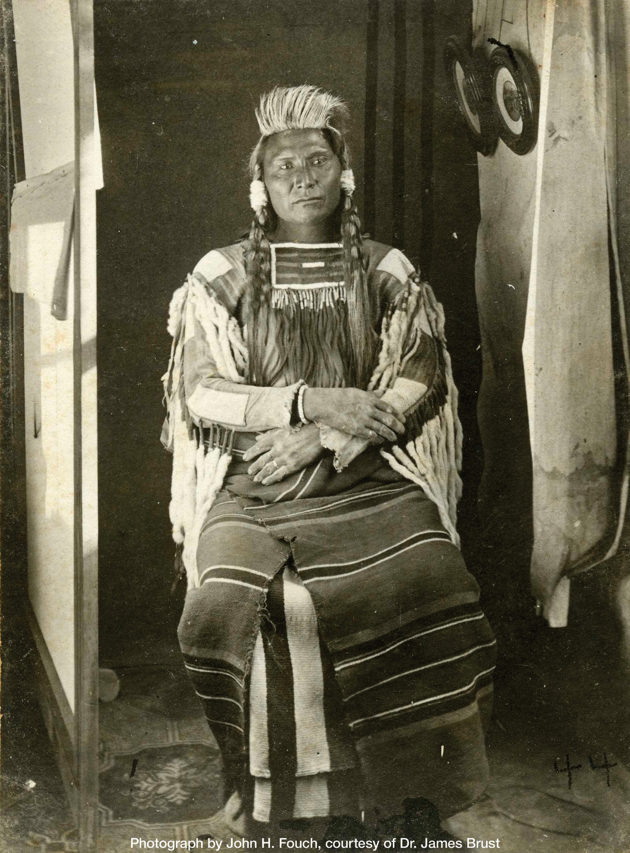

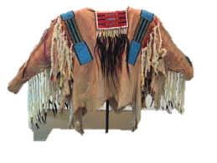

An article in the Seattle Post-Intelligencer newspaper of June 25, 1905 describes the event:

The Chief Joseph potlatch took place Friday. It was one of the greatest affairs of the kind we have any record of. The huge council lodge was filled. At the head of the lodge were gathered heaps of the worldly possessions of the late Chief Joseph. … After dinner speeches were made, the crowning of which was made by Chief Yellow Bull. The speech was made on horseback while the old chief rode slowly three times around the outside of the big council lodge. He rode Chief Joseph’s faithful old horse and besides that dignity he wore all of Chief Joseph’s war clothes, including the famous eagle feather war bonnet. His speech related almost wholly to the greatness of the man whose clothes he was wearing. …

The great war bonnets and war clothing went to the three nephews. A dozen watches were among the gifts, three fine guns and an endless array of blankets. One of the three buffalo robes was given to Three Knives, or Professor Meany.

So presumably this shirt passed into the hands of one of Chief Joseph’s nephews in 1905, but there is no record of it after that for another 90 years. Its prominent presence in national iconography notwithstanding, the shirt disappeared into the market and was purchased by a collector at an Indian relic show some time in the 1990s. Neither the seller nor buyer had any idea of who had worn this shirt and when. It was sold purely as an exquisite Native American craft in excellent condition. That collector then sold it to another collector who researched the piece thoroughly and was able to identify it as the shirt worn by Chief Joseph in the 1877 picture and the 1878 oil painting. Experts confirmed that it could not have been a later forgery based on the images. The crafts and materials simply cannot be duplicated.

Mystery Envelope Clues